**Coalesce() function in sql server - Part 16**

According to the MSDN Books online COALESCE() returns the first Non NULL value. Let's understand this with an example.  
  
  
Consider the Employees Table below. Not all employees have their First, Midde and Last Names filled. Some of the employees has First name missing, some of them have Middle Name missing and some of them last name.  
  
  
  
  
  
  
  
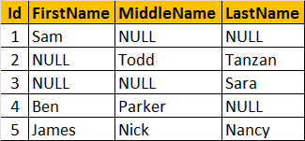  
  
  
Now, let's write a query that returns the**Name of the Employee**. If an employee, has all the columns filled - **First, Middle and Last Names**, then we only want the **first name**.  
  
If the **FirstName is NULL**, and if **Middle and Last Names are filled** then, we only want the **middle name**. For example, Employee row with Id = 1, has the FirstName filled, so we want to retrieve his FirstName "Sam". Employee row with Id = 2, has Middle and Last names filled, but the First name is missing. Here, we want to retrieve his middle name "Todd". In short, The output of the query should be as shown below.  
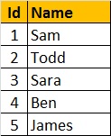  
  
We are passing **FirstName, MiddleName and LastName** columns as parameters to the COALESCE() function. The COALESCE() function returns the first non null value from the 3 columns.  
**SELECT Id, COALESCE(FirstName, MiddleName, LastName) AS Name**  
**FROM tblEmployee**